www.oscar1.com

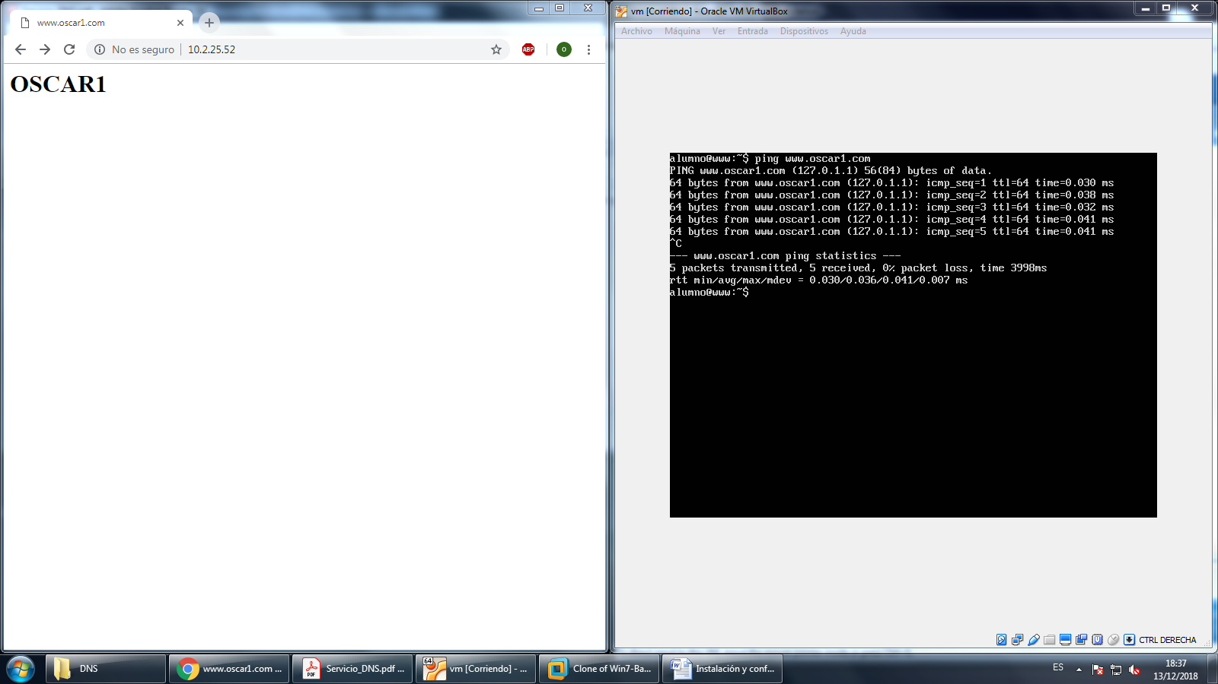

[www.oscar2.com](http://www.oscar2.com)

